WEST LONDON WASTE AUTHORITY
Report of the Projects Director | 22 March 2024
Food recycling projects update

SUMMARY
This report provides an update on the Authority’s Food Waste investment in Borough Business Cases, approved in September 2020.
- Individual borough food waste project progress
- Boroughs are delivering returns through food waste reduction and diversion
- Delays have hindered some boroughs projects and returns
RECOMMENDATION(S)
- Note the information within this report.
- Introduction – In 2020 the West London Waste Food Waste investment approved £3m of reserves to fund investment in borough food waste services and increase food waste collection.
- Background - There are many factors that impact how residents deal with their food waste. These include factors within the control of councils, such as access to a food recycling collection service, as well as the availability of good quality information and equipment to use the service. Other external factors will also influence how residents act, and can be often impacted by factors such as food consumption behaviours, perception of collection services and household income.

Using the data available, it is possible to measure the overall trends of food waste generation, as well as the following factors:
- Separate food recycling collected – the quantity of food waste residents put in their food recycling service
- Proportion of food in the residual – how much food waste residents put in their rubbish bins
- Capture rate – how much of the total food thrown away is collected in the food recycling service
- Residual waste – the quantity of waste residents throw away
- Access to service – what proportion of households in the borough have access to kerbside or communal food waste services
Each of these metrics have an impact on the financial returns of borough food recycling services, and therefore need to be considered together.
- Food projects updates
In 2020 the boroughs submitted project business cases setting out how the funding would be used to increase separately collected food waste for recycling, with the aim of significantly reducing the volume of food collected in the residual waste stream. Each project included key actions to monitor project progress against. These were assessed against performance criteria to calculate potential return on investment (ROI) based on assumptions about the weight of food waste available in the collection system. Since 2020 there have been external factors and internal changes in many boroughs which have resulted in some changes of project scope or timetable. This section outlines the status for each individual food recycling project up to the end of February 2024 and is based on information provided by the boroughs.

Brent
Project Summary | Brent have successfully established a new collections contract with Veolia and are in the process of rolling out food waste to collections to communal properties. Further assessment of communal property data found that fewer properties are within scope than initially estimated, so the target has been revised to provide an additional 39,000 flats with equipment and consumables to increase the utilisation of the collections service. Brent have developed a staggered delivery schedule and have commenced Phase 1, which involved procurement of 10,400 caddies. Brent have committed to full delivery by the end of 2024/25.
Targets |  | Results
Provide a kerbside food recycling service to an additional flats 39,000 |  | Brent have started the procurement for consumables and containers but currently no additional properties have been added to the service
Project spend |  | £34,175 – caddies, liners and vehicle livery banners

Ealing
Project Summary | Ealing have successfully supplied caddies, caddie liners and leaflets containing targeted communications to 25,000 targeted non-participating households. In addition, Ealing have introduced a food recycling service to over 11,000 properties across 401 locations. Ealing plan to extend the service to new builds and communal properties without open access in order to reach the target of 20,000 properties added to the communal service by end of 2024/25.
Targets |  | Results
Provide a food recycling service to an additional 20,000 flats |  | 11,365 flats added to the service
Targeting non-participating households on all collection rounds with caddies, caddie liners and leaflets. |  | 3,853 properties were identified and targeted (complete)
Project spend |  | £340,488

Harrow
Project Summary | Harrow have installed bin units at communal properties to expand the food recycling service available for flats and flats above shops. Harrow are also expanding the food recycling service to more schools and businesses. Harrow have made steady progress on the rollout and are expected to exceed the targets by the end of 2024/25.
Targets |  | Results
Provide a food recycling service to 250 businesses and schools |  | 124 new businesses are receiving the service
Provide food recycling service to 5500 communal properties |  | 5,048 flats in communal properties have been added to service
Provide food recycling service to 1000 flats above shops |  | 588 flats above shops have been provided with a service
Project spend |  | £469,923

Hillingdon
Project Summary | Introduce separate kerbside food service to homes either with no service or currently receiving a mixed organic service.
Targets |  | Results
Introduce a separate food waste service to all properties that previously received a mixed organics service |  | The service was introduced in May 2021
Procure five top loader vehicles to facilitate separate food and green waste collections |  | Complete
Provide kerbside collection service to 30,000 new subscribers |  | 41,896 (140% complete)
Project spend |  | £500,000

Hounslow
Project Summary | - Introduce service to 24,500 flats that currently do not receive a food recycling collection service.  - Supply of new equipment and targeted communications to 10,500 homes in 5 current collection rounds to improve volumes collected i.e. efficiency.
Targets |  | Results
Introduce service to 24,500 flats |  | 24,500 flats are now receiving the service
Purchase 2 vehicles to collect the bins as part of the bin exchange and cleaning service |  | The service commenced in April 2022
Improved behaviours towards food waste recycling in 5 current collection rounds to increase volumes collected |  | - Limited participation monitoring targeted 440 non-participating kerbside properties in September 2021 and three further wards in February 2022.  - A targeted communication campaign was carried out in the Brentford Dock estate to increase the amount of food collected to 1kg/hh/wk, the impact was monitored by bin sensors.
Project spend |  | £500,000

Richmond
Project Summary | Richmond have seen a change in contractor at the commencement of the project. The mobilisation of the new service and contractor has led to a delay in the expansion of the service and therefore the food project.  - Provide 17,000 flats with equipment and consumables to increase utilisation of the collection service  - Introduce a commercial waste collection service to 540 new commercial customers  - Identify non-participating households on the 5 lowest performing rounds and target communications and collection material such as caddy at these households
Targets |  | Results
Introduce service to 17,000 flats |  | 5,603 flats have been added to the service across 247 blocks
540 businesses |  | Currently on hold
Target non-participating households |  | Completed – 25,000 properties surveyed
Project spend |  | £235,846

West London Waste Authority
To support the progress of these projects WLWA has:
- Procured and installed a bin wash system at Transport Avenue, which is currently being utilised by Hounslow and Richmond.
- Provided fleet routing and efficiency services for integration of new properties on rounds and new services.
- Provided communications support and resources for food waste services.
- Financial Implications
As detailed in the background section above, it’s not possible to use one measure to capture the full financial implications of food waste being thrown away. Each of the measures described would independently deliver savings on disposal or reprocessing costs.
The calculations used in this section measure food waste data variance against the baseline, and therefore cannot be used as a measure of absolute performance of borough food recycling services. Each borough commenced its food waste project at a different time, and continue to operate differently.
Nevertheless, interpolating this data and available metrics is essential to understanding and tracking any trends in waste reduction, service maturity and performance.
Tonnage of separate food recycling collected through borough services
Food waste trend from year-on-year change analysis
Despite some fluctuations, there is a general increasing trend in food waste tonnage collected year-on-year, which is highlighted by the trend line below (Figure 1). Year-to-year there are some notable differences: there are variations in the food waste tonnages collected for the same months across different years. For example, April 2020-21 compared to April 2021-22. The inclusion of the food waste collected separately by Hillingdon explains a significant proportion of this growth trend. In addition, there are consistent seasonal variations in the amount of waste generated, with higher tonnages typically reported in the summer months and lower tonnages reported during the winter months. This seasonal trend may be attributed to changes in consumption patterns throughout the year, weather conditions or holiday festivities.

Figure 1 – Food waste tonnes collected quarterly over the past 4 financial years with trend line.

Change in food collection since 2020
A total of 8,733 additional tonnes of additional food waste has been separately collected for recycling since the pre-pandemic baseline year. The baseline used takes an average of 2018-19 and 2019-20 to reduce the impact of one-off events. The potential savings calculated below are based on the assumption that food waste tonnage has moved from the residual waste stream to the food waste service.
Table 1:
Additional food waste tonnage collected in the food recycling services up to December 2023 versus baseline figures ending in April 2020
Borough | Tonnes | Savings (+ve)/growth (-ve) in residual waste costs as a result of food being separated
Brent | -790 | -£90,112
Ealing | 779 | £88,841
Harrow | -2,336 | -£266,359
Hillingdon | 9,552 | £1,088,898
Hounslow | 2,085 | £237,727
Richmond | -557 | -£63,480
WLWA | 8,733 | £995,515

Proportion of food in the residual waste
The absolute volume of food waste captured for recycling only covers a proportion of the full food waste system. Food waste generated in households across west London predominantly flows through two routes: the food recycling service or into the residual waste stream via the rubbish bin. Every 15 months a waste composition analysis is undertaken to understand the composition of the residual waste stream. The most recent waste composition analysis was conducted in December 2023, and the general west London wide trend in food waste capture can be seen below (Figure 2).
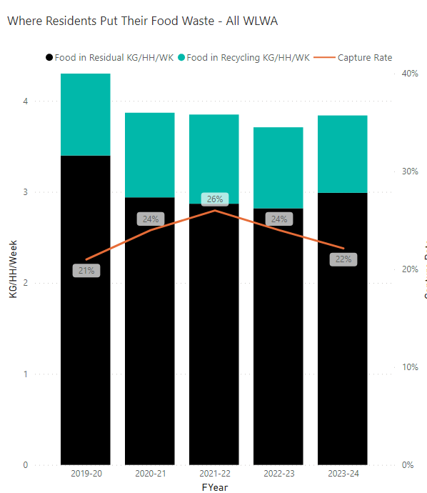
Figure 2. Trend for food waste capture across west London boroughs over financial years. This data has been generated using waste composition analyses, which are completed every 15-months.
Capture of food
The capture rate indicates how much of the total amount of total food waste across the entire waste system is being collected by the food waste service. A high capture rate of over 50% would indicate that more than half of the food waste in the entire waste system is being separately collected by the food recycling service, Using the tonnage data from food recycling services and the waste composition analysis for each of the last four years, a capture rate for food being thrown away can be measured as a snapshot in time. The figure below show the total amount of food being thrown away had been reducing gradually year on year, and the proportion of it being placed in the food recycling service was increasing (Figure3 3). However the results from the most recent waste composition analysis in December 2023 indicate a slight increase in volume of food being thrown away as well as a decrease in the proportion being placed in the food recycling system. This trend may be attributed to seasonal variability – although food waste generation is higher during the summer months, there are also consistently high levels of food waste production during the month of December, likely linked to holiday festivities.
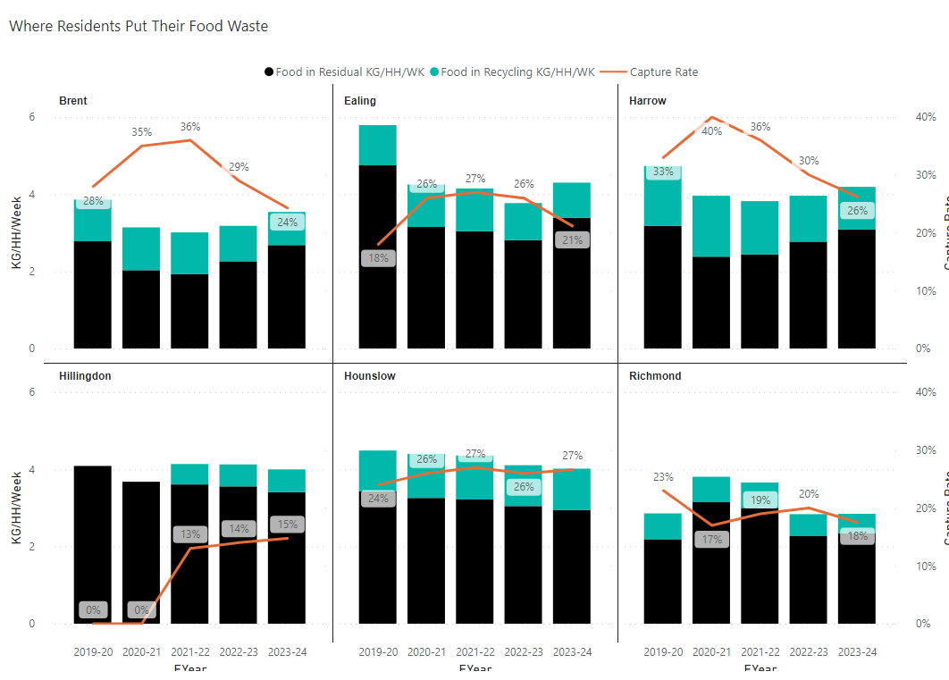
Figure 3. Trend for food waste capture across individual west London boroughs over financial years. This data has been generated using waste composition analyses, which are completed every 15-months.

An increase in capture rate supports the increase in participation through the expansion of the services by boroughs. The trends suggest the importance of ongoing monitoring and analysis of food waste generation, and also highlights the importance of food recycling collection expansions and support for residents through behaviour change campaigns.

Table 2 shows the reduction or growth in the amount of food being thrown away in the residual waste bins since the baseline year, and the associated cost or saving of disposing/reprocessing that material.
Table 2:
Food waste reduction in residual (based on waste composition data)
Borough | Tonnes | Savings (+ve) /growth (-ve) in residual waste costs as a result of less food being thrown away in the residual waste
Brent | 25,507 | £3,188,316
Ealing | 50,021 | £6,252,613.20
Harrow | 9,551 | £1,193,894
Hillingdon | 10,383 | £1,297,926
Hounslow | 9,711 | £1,213,916
Richmond | -8,984 | -£1,122,966
WLWA | 96,190 | £12,023,700

- Access to collections
One significant measure to increase food waste collection and reduce food waste volumes in residual waste is to ensure all households have access to food recycling services. All West London boroughs have made significant progress over the course of the last four years to expand food recycling services to residents (Table 3).
Table 3. The proportion of households/properties currently receiving a food waste recycling service across communal (flats and flats above shops) and kerbside services.
Borough | Total households | Households with communal food collections | Households with kerbside food | Total households with food collections | Proportion of all properties with food service
Brent | 114,420 | 11000 | 90,000 | 90,000 | 78%
Ealing | 130,385 | 11,365 | 95,000 | 106,365 | 82%
Harrow | 96,946 | 5,048 | 74,441 | 79,489 | 82%
Hillingdon | 114,860 | 671 | 45,536 | 46,207 | 40%
Hounslow | 107,000 | 26,531 | 74,095 | 100,626 | 94%
Richmond | 85,370 | 5,407 | 66,000 | 71,407 | 84%

It is difficult to model the uptake of food waste services but at the current participation rates of c.22%, all properties having access to the service would remove a further c.7000tpa of food from the residual waste.
- Staffing Implications – None
- Health and Safety Implications – None
- Legal Implications – The Environment Act 2021 includes a requirement for every household to receive a separate food waste collection service. The projects identified are leading best practice for flats and flats above shops food waste collections services.
- Joint Waste Management Strategy
A key factor in the Joint Waste Management Strategy is the 65% recycling target. To meet this a framework of a joint plan for 2030 to be developed by WLWA and Boroughs was agreed in March 2022. The joint plan must incorporate managing the rising cost of inflation which can only be countered in WLWA by reducing the amount of waste collected.
It is vital in this year that we:
- Increase the proportion of residents using the food waste service and
- Prevent waste at source in the recycling centres.

The agreed framework is shown below:
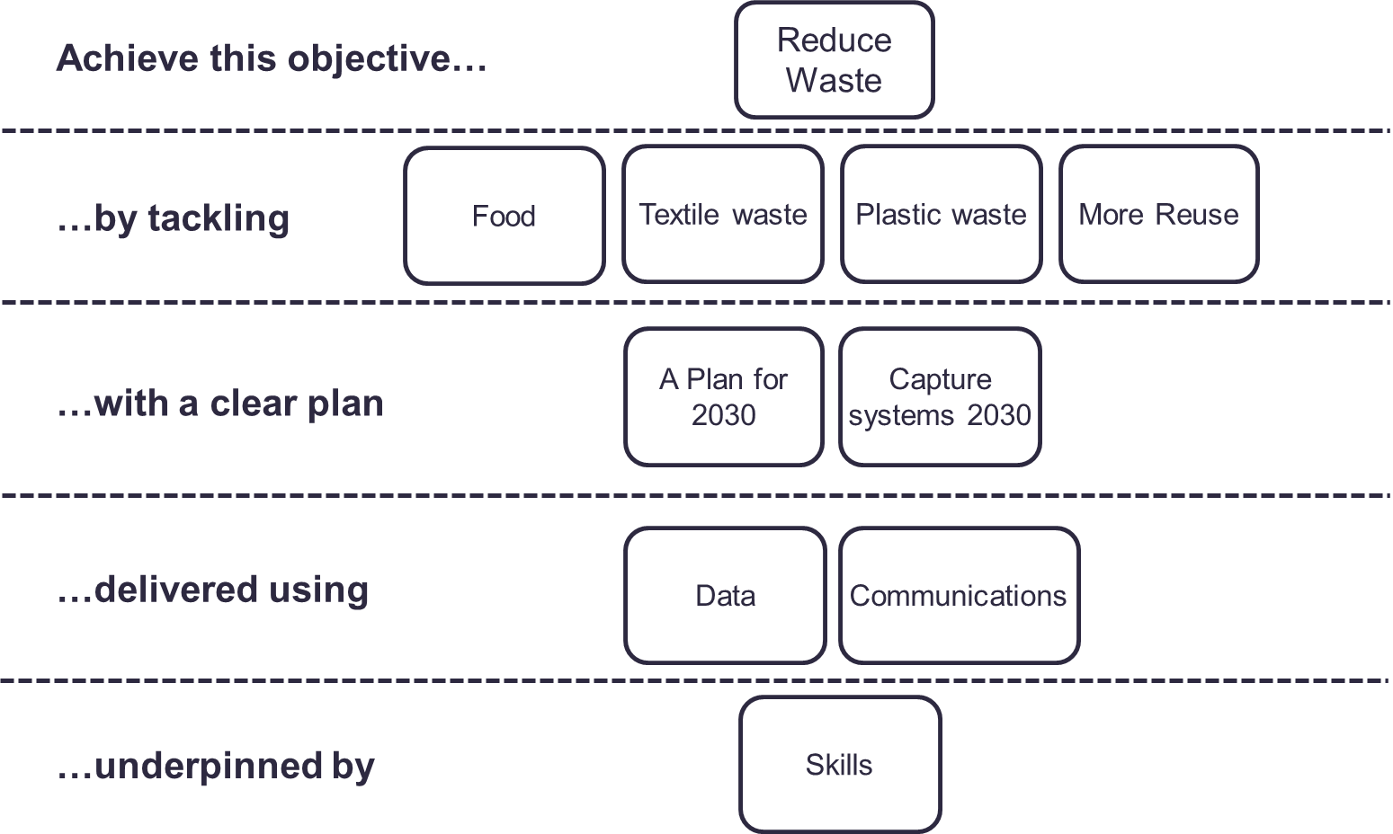
The food service is intrinsically linked to the Authority’s Joint Waste Management Strategy and Business Plan. The projects are driving the design of the new policies and programmes through data, best practice and identification of opportunities, as well as delivering change to meet the desired outcomes and targets in the Strategy and the proposed Budget.
- Impact on statutory, national and London targets
Improvements in capturing food waste helps towards the target of 65% recycling by 2035 (2030 in London).

Contact Officers | Peter Tilston, Projects Director 01895 545510  petertilston@westlondonwaste.gov.uk  Stella Pyke, Project Manager  StellaPyke@westlondonwaste.gov.uk

